**6.3 SQL Functions**

This week, we will learn how to use functions in SQL.

2.Use the SalesOrderDetail table to find the total quantity sold of each item.

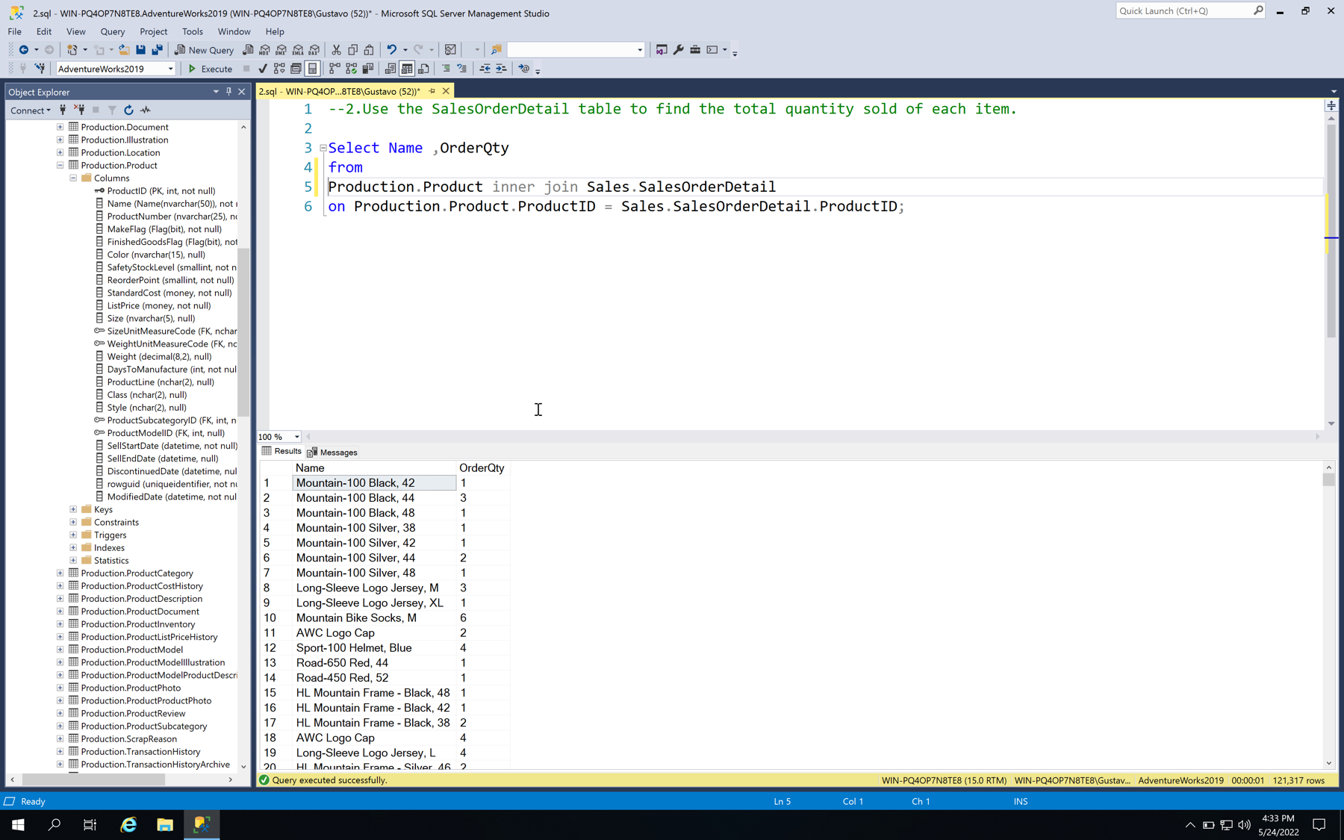

4.Find the total number of people with a suffix in their name.

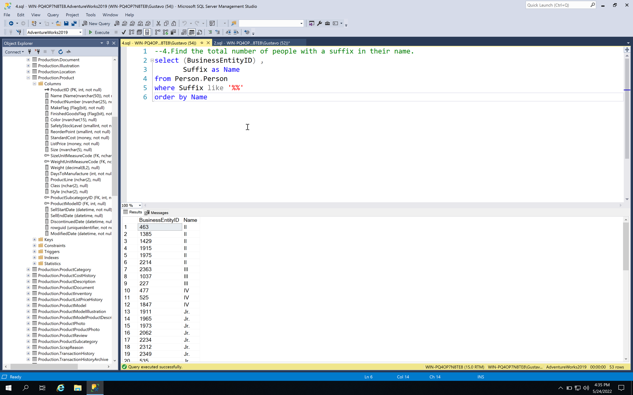

5.Use the product table to find all the subcategories that contain more than 10 products.

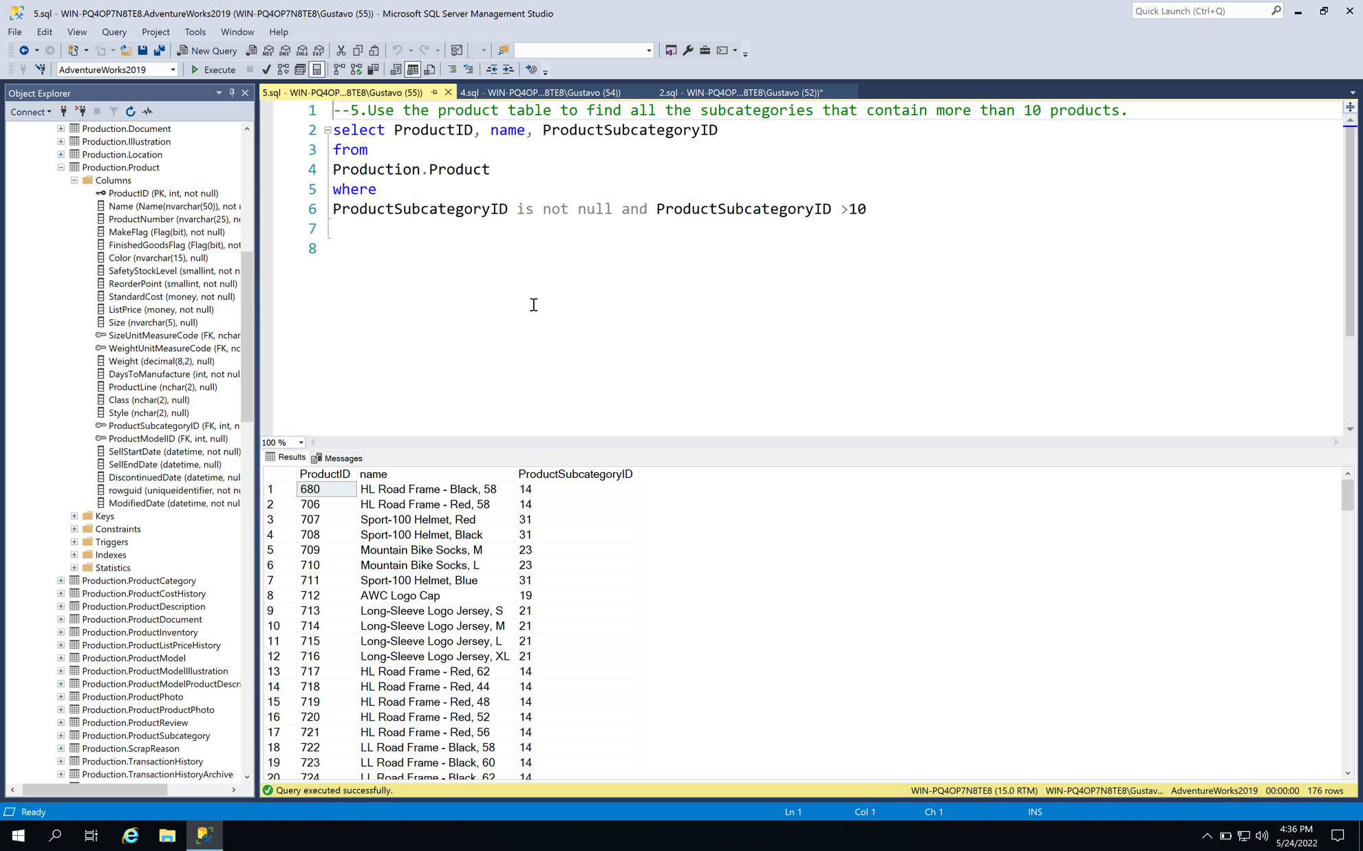

6.Find the total accumulated vacation and sick hours for each jobtitle

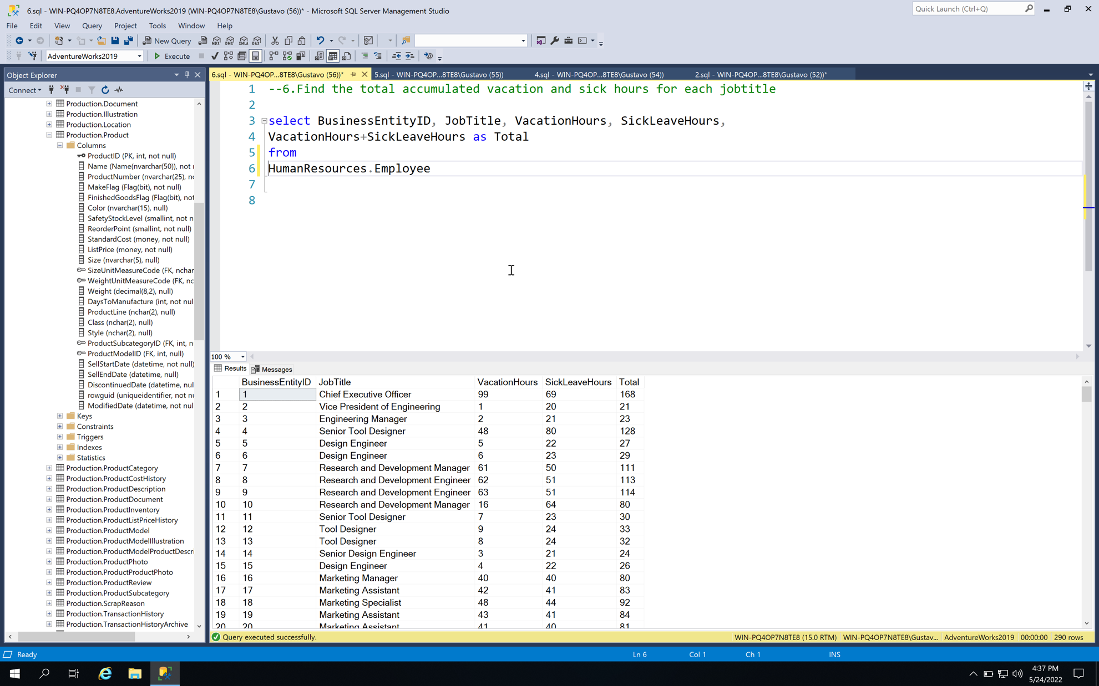

9.In the sales order detail table, find the largest, smallest, and average amounts sold by product ID.

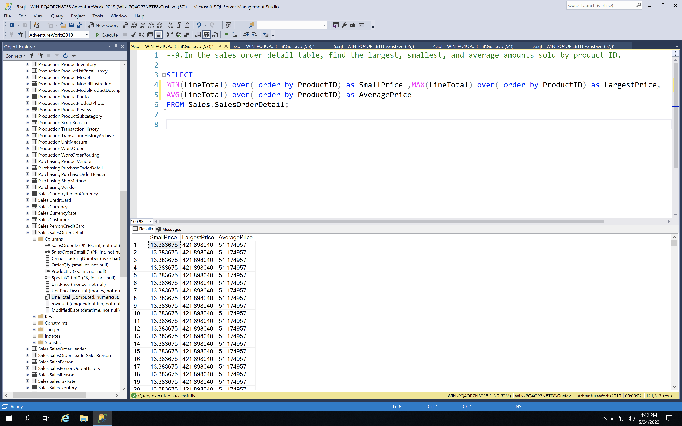

10.Use the product table to find all colors with more than 20 products

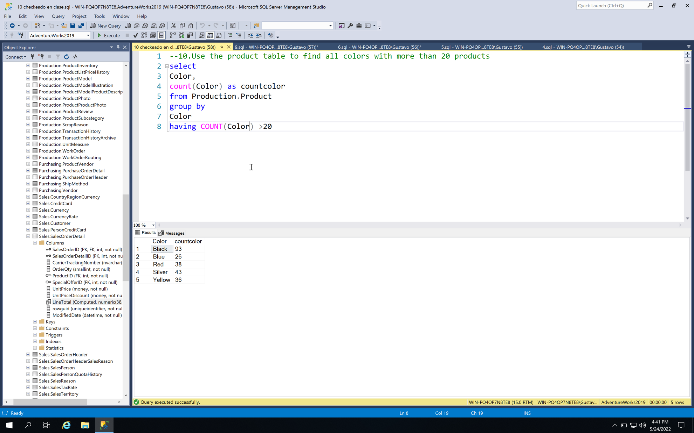

11.Use the sales order detail table to find the total quantity sold for each day of the year 2013

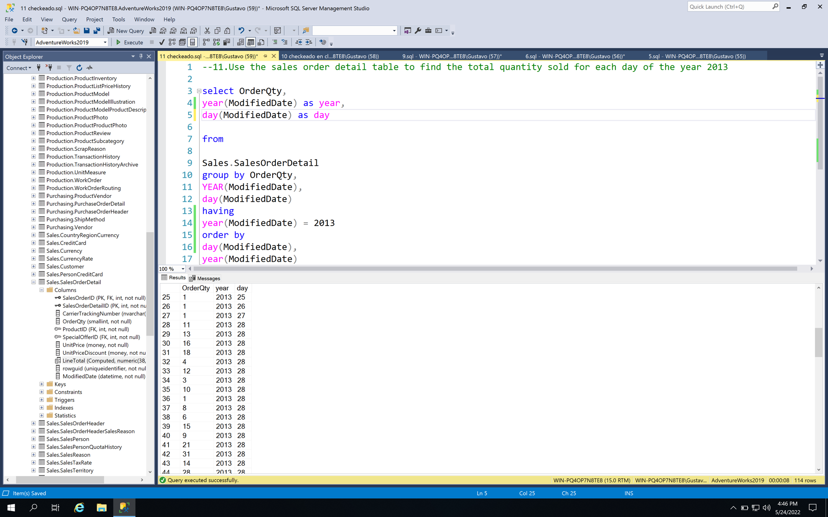

12.Find the length of each product name in the products table.

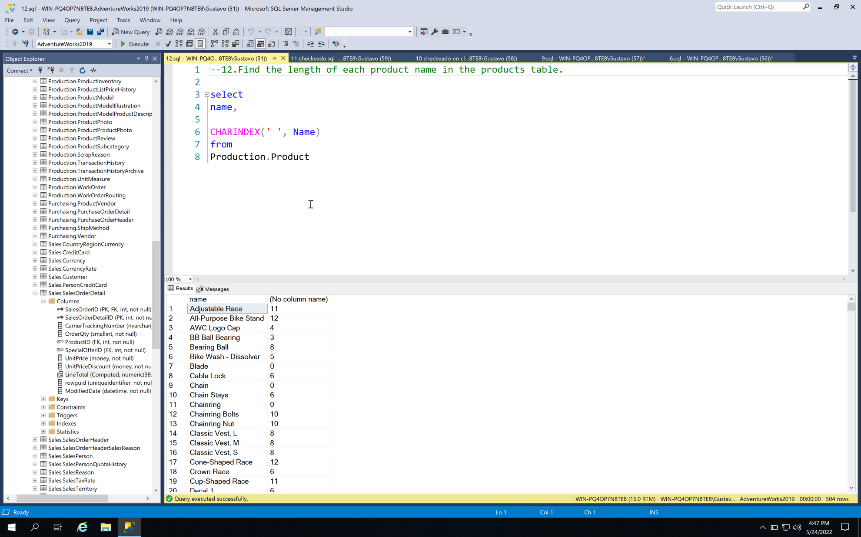

13.In the products table, find the length of the name of each unique product color

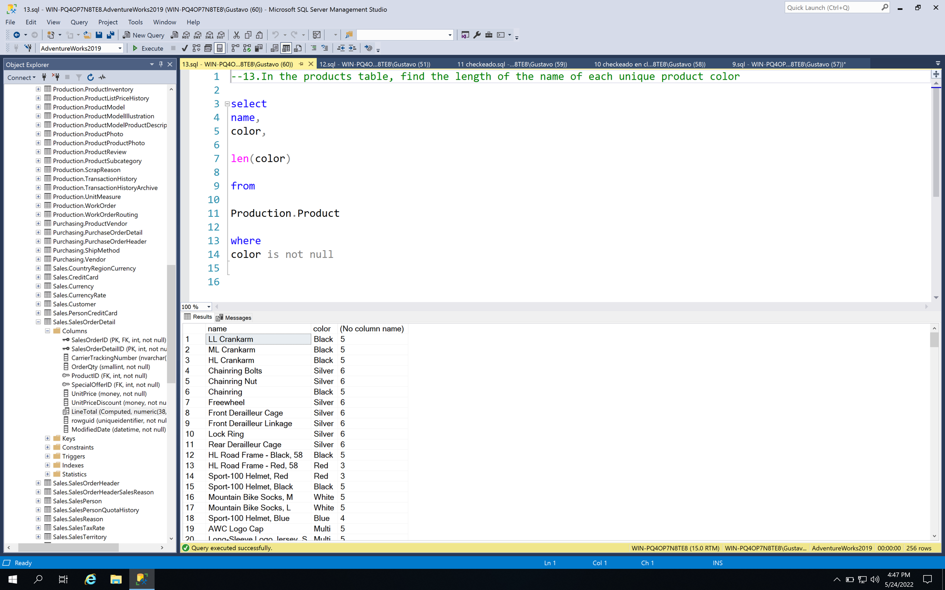

14.Find the highest standard cost in the products table

